Web Development

(Project Man Friday Deli)

By Matthew O’Connell Cantillon

CADVS2

Contents

Design 2

Testing and Construction 2

Conclusion, Final thoughts, Changes 5

Website: <https://cantillon.coccork.ie/home/>

Username: [matthewcantillon@morrisonsislandcampus.com](mailto:matthewcantillon@morrisonsislandcampus.com)

Password: J4vG#2IiyUr(y52w

# Design

*D*esigning the website was the more difficult part of this project, my first idea was to check out the website made for the Kinsale Restaurant and see if I can link them with a small detail

So, people know they are together but also separate.

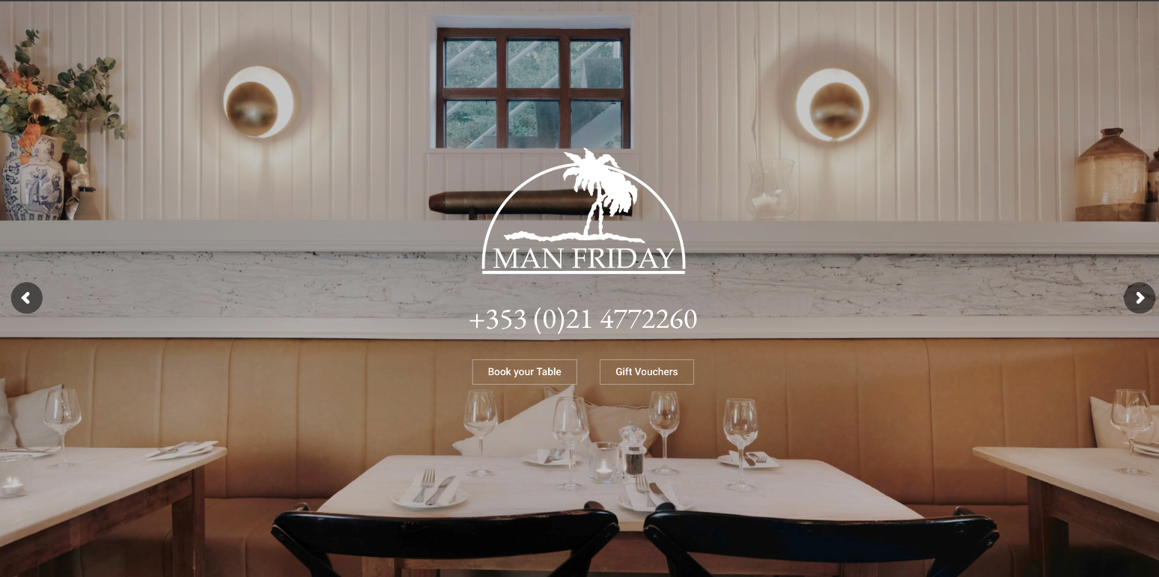

This is a screenshot from the Kinsale Website, I took some notice of the colors used as well as the Tree Icon

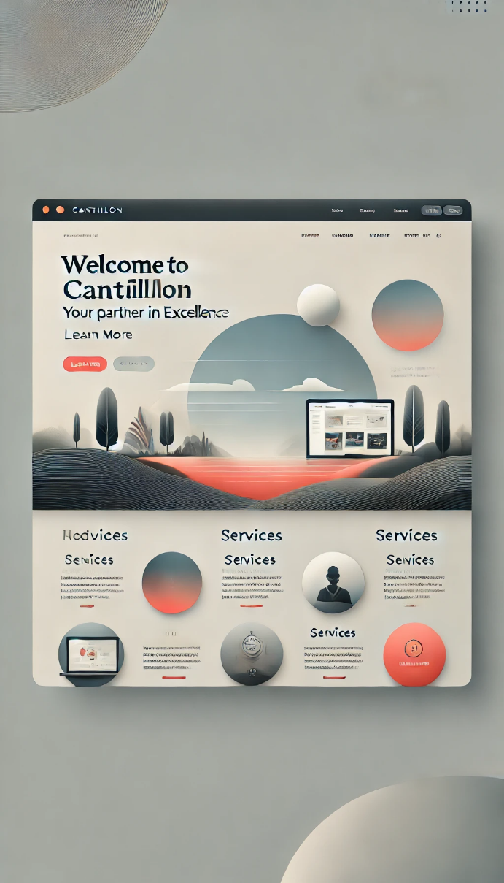 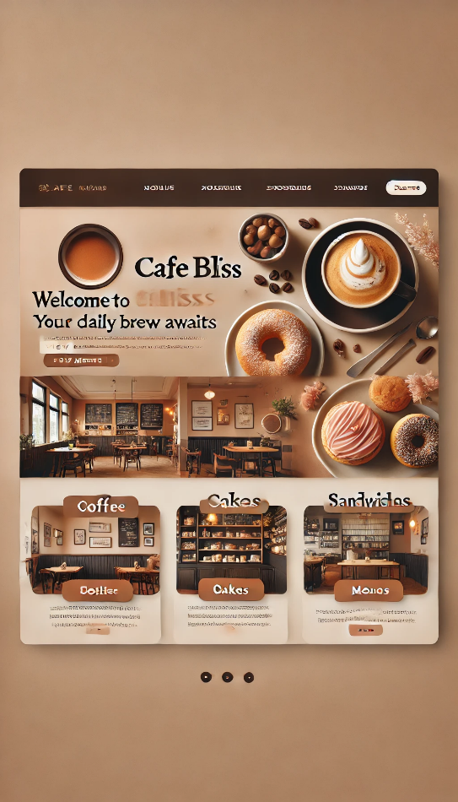

I also asked our good dear friend ChatGPT and gave it some ideas and asked it to design a home page, to see what it could think of, and I certainly got some response.

While this is a little bit weird and dare, I saw a bit creepy to look at, I did take some ideas.

* Again, the darker brown mixed with yellow colours
* The idea of having a logo and the most used sites up top
* Trying to make it clear and easy to navigate
* Buttons

# Testing and Construction

In the nicest way ever, WordPress is such a hogger of Wi-Fi among other things

I did find issues working with both Astra and Elementor, sometimes widgets worked on one but didn’t on the other, or sometimes it just decided that today was enough and crashed.

This was a good reminder to save every time I did anything

The home page was kept quite simple, I wanted it to be an easy website to load into and use, I did put more detail and work into the mobile part of it, as i believe that’s where its going to be accessed most

This is the home page on a 14-inch MacBook screen

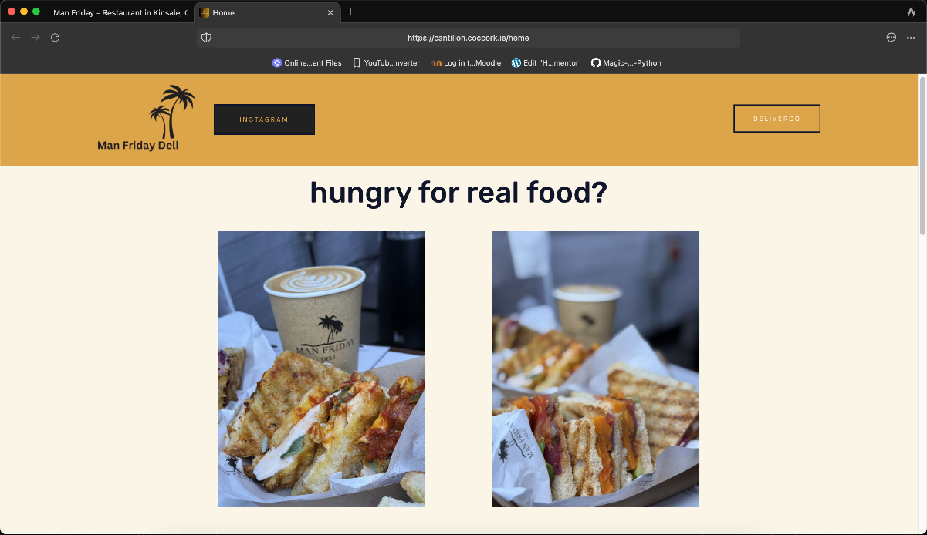

Its pretty simple, a bit basic but nothing too shouty or hugely attention grabbing

* It does offer a neat top bar with easy access to the Instagram and Deliveroo
* The photos are neatly laid out and nothing feels overwhelming
* Text is easy to read (I wish it would capitalize but we can’t have everything)

Now this is the same page on a smaller Apple iPhone

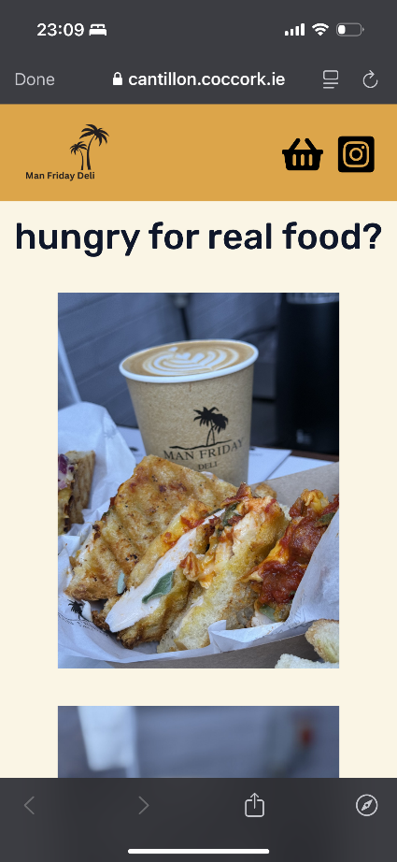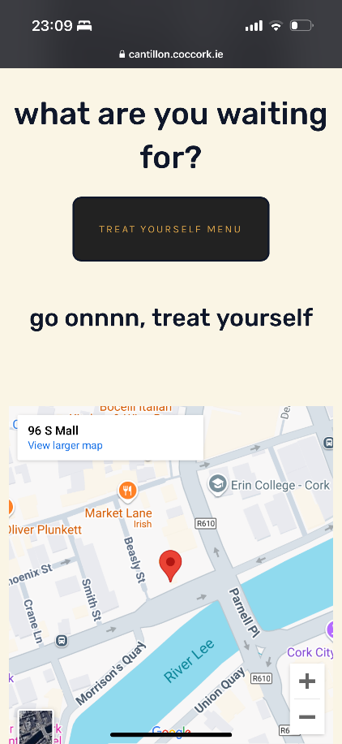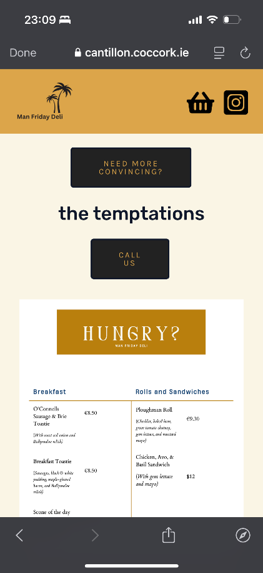

and a Large Google Android phone

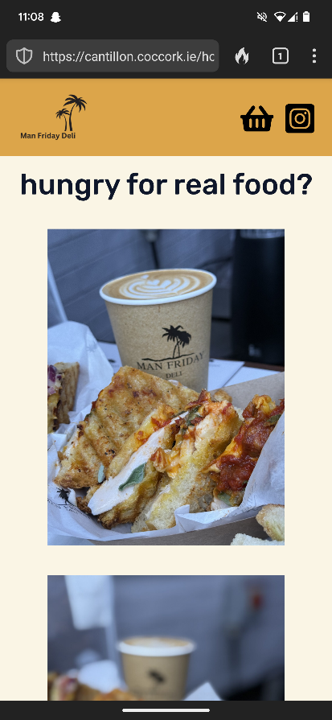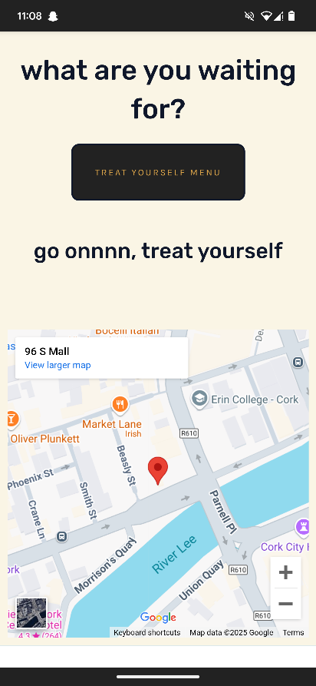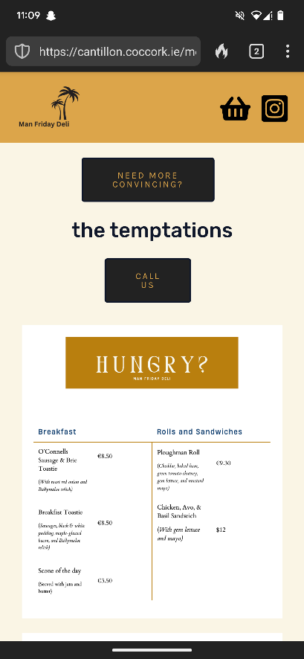

On the phone screens it does seem better equipped, it uses the space better and just feels nicer to navigate, and the call us button takes advantage of phones being able to make calls.

# Conclusion, Final thoughts, Changes

Overall, this was a lot of fun, the café is quite nice inside and while the opening and closing times are a little annoying the food is lovely

I’m happy with how my website came out, I think it works well, and I am a fan of the clean simple design I was aiming for

However

* The laptop interface could be a bit better; it does give the feeling that it wasn’t made primarily for a bigger screen
* The call-to-action button could do more things, such as maybe a way of pre-ordering or a click and collect menu
* Maybe change it up a bit next time and try and make it feel more exiting, even though this is a simple café website